EVENTLOG COP 1.00
USER GUIDE
01/04/2005

© Martin Budař, 2004

http://www.eventlogcop.net
eventlogcop@budar.cz

This software is provided for free. You can install it on an unlimited number of computers and use it for monitoring of an unlimited number of hosts. However, it’s strictly prohibited to sell or to modify it without the author’s written permission or to use any part of it in any third party commercial application.
This software is provided "as is", without any guarantee made as to its suitability or fitness for any particular use. It may contain bugs, so use of this tool is at your own risk. The author takes no responsibility for any damage that may unintentionally be caused through its use.

Content
1. Content 2
2. Introduction 3
2.1. Main features 3
2.2. Structure of the application 3
3. Requirements 5
3.1. Server 5
3.2. Monitored computer 5
3.3. Client 5
4. Installation instructions 6
4.1. License 6
4.2. Download installation files 6
4.3. Prepare service account 6
4.4. Prepare database server 6
4.5. Prepare database 7
4.6. Install the EventLogCop service 8
4.7. Install WebGUI 9
5. Un-installation instructions 12
5.1. Un-install WebGUI 12
5.2. Un-install EventLogCop service 12
5.3. Un-install database 12
6. Setting permissions on monitored hosts 13
6.1. Windows 2000 Professional, Server and Windows XP 13
6.2. Windows 2003 Server 13
7. Web GUI Description 15
7.1. EventLog Cop Main Page 15
7.2. Reports 15
7.3. Collectors 17
7.4. Detail of Collector 18
7.5. Groups 19
7.6. Detail of Group 20
7.7. Alerters 21
7.8. Detail of Alerter 22
7.9. Options 23
7.10. Export/Import 23

Introduction
EventLog Cop is a smart, easy to use utility for monitoring of event logs in Windows 2000, 2003 and XP computers. It allows monitoring of all important event logs across your network from one place in a convenient way.

Main features
- It’s a simple, web based application. With Internet Explorer you can see all important event logs from one place, using an easy-to-use reporting system.
- It supports Windows 2000, XP and 2003 operating systems, both workstations and servers.
- You don’t need to install any client software on monitored servers or workstations – EventLog Cop uses only native built-in Windows services and protocols.
- The data are stored at MS SQL Server 2000, or MSDE, which provides great reliability and performance.
- The easy to use, highly customizable Alerts system keeps you informed by e-mail whenever any important event occurs.

But the main advantage compared to competing products is:

EVENT LOG COP IS FREE!

It can be installed on an unlimited number of computers; it can be used for monitoring of an unlimited number of hosts – and you pay nothing for it!

However, it’s strictly prohibited to sell it or to modify it without the author’s permission or to use any part of it in any third party commercial application.

Structure of the application
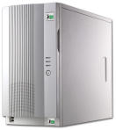


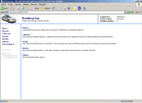
Windows Servers or Workstations
EventLog Cop
Windows Service
MS SQL database
Web GUI

The application consists of three parts:

- SQL database, where all data and settings are stored.
- EventLog Cop Windows Service, which gathers events from monitored hosts, stores them in the SQL database and eventually sends the Alerts when defined conditions are met.
- Web GUI, designated for EventLog Cop configuration and reporting.

Requirements
To run the EventLog Cop application you need the following software installed.

Server
- Windows 2003 Server,
- IIS 6.0 (part of Windows 2003 Server),
- Microsoft SQL Server 2000 SP3 or MSDE 2000 SP3.

Monitored computer
You do not need to install any piece of software on computers you want to monitor. The following operating systems are supported:

- Windows 2000 Professional and Server,
- Windows XP Professional,
- Windows 2003 Server.

Client
- Internet Explorer 6 SP 1 or later.

Installation instructions

License
This software is provided for free. You can install it on an unlimited number of computers and use it for monitoring of an unlimited number of hosts. However, it’s strictly prohibited to sell or to modify it without the author’s written permission or to use any part of it in any third party commercial application.
This software is provided "as is", without any guarantee made as to its suitability or fitness for any particular use. It may contain bugs, so use of this tool is at your own risk. The author takes no responsibility for any damage that may unintentionally be caused through its use.

Download installation files
Please download the eventlogcop_install.zip file from http://www.eventlogcop.net. Unzip it to some temporary folder (e.g. c:\temp or d:\temp) on the server, where the application will be running.

Prepare service account
Create a domain account. This account will be used for running the EventLog Cop main service and ASP.NET worker process for Web GUI.

The account needs the following rights:

Active Directory Domain
- Member of Domain Users group.

Server
- Member of IIS_WPG local group.
- “Modify” access permission for folder where the application files are stored (C:\Program files\EventLogCop by default).

Monitored Host
Please check the “Setting permissions on monitored hosts” chapter to set appropriate rights.

Prepare database server
You need Microsoft SQL Server 2000 SP3 or MSDE 2000 SP3 to run the application. The Microsoft SQL Server 2000 Desktop Engine (MSDE) is included in the full installation package of the EventLog Cop application. You can use either an existing instance or install new one. The default installation with “Windows Authentication” only is enough. Please do not forget to install all security hotfixes to tighten security of your network. Check http://www.microsoft.com/technet/security/ for more info.

MSDE installation instructions (optional)

- Run the InstallMSDE.exe file from the “msde” subfolder of the temporary directory (e.g C:\temp\database).

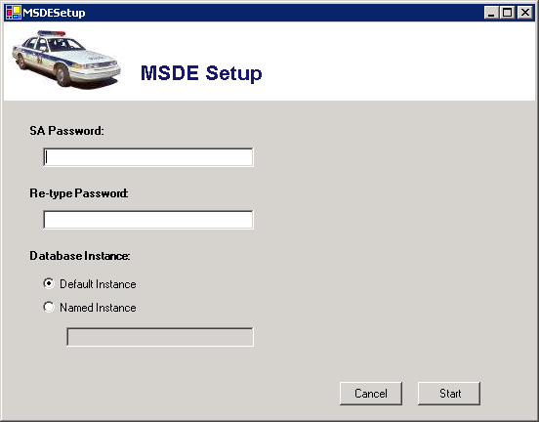

- Fill in the SA (system admin) Password. For security reasons, the password should be at least 6 characters long and should contain both characters and numbers.
- Choose Database Instance. Default instance is recommended. You usually need the Named instance only in case you want to run more installations of the MS SQL Server on one computer at the same time.
- Press Start button and accept the Microsoft License Agreement. The MSDE will be installed into the C:\Program Files\MS SQL Server directory.
- Wait until the MSDE is installed.
- Restart the server.

Prepare database
Run the InstallDB.exe file from the “database” subfolder of the temporary directory (e.g. C:\temp\database).

ATTENTION!! You need to run the InstalDB.exe utility from the local disk on the server where the database is running! Otherwise the application will not work properly.

Fill in the following data:

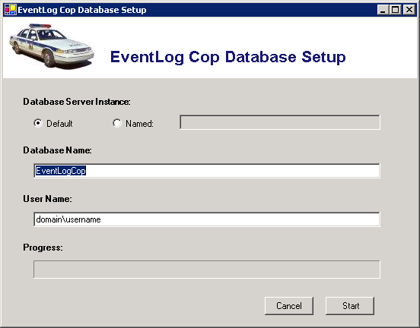
- Database Server Instance. Usually you will use the Default instance. Otherwise please type the name of Named instance.
- Database Name – enter the name of the database you want to store the data. It’s recommended to leave the default name EventLogCop.
- User Name – enter the name of the user you created previously in the form of domain_name\user_name (e.g. mydomain\eventlogcop).

Click the Start button to begin database installation.

Install the EventLogCop service
- Copy the content of the “service” subfolder to the C:\Program Files\EventLogCop.
- Set the “Modify” permissions for the user you created previously to that folder.
- Run the RegSvc.exe file. When asked, enter the user name and password of the user you created previously in the form of domain\user.

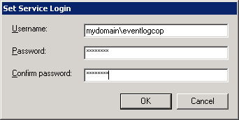

- Wait until the “Registration completed successfully” message is displayed.

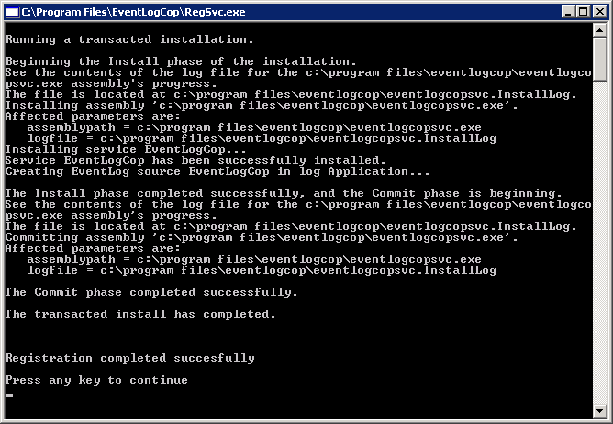

- Open the EventLogCopSvc.exe.config file in Notepad.
- Modify the line:
<add key="dbc.ConnectionString" value="data source=sqlserver;initial catalog=EventLogCop;integrated security=SSPI;persist security info=False;packet size=4096" />
Enter the following two values: data source=name of your database server
initial catalog=name of the database you created
- Open Administrative tools -> Services console, locate EventLogCop service and start the service.

Install WebGUI
- Copy the “WebGUI” subfolder content to C:\Program Files\EventLogCop\WebGUI.
- Open Web.Config file in Notepad.
- Modify the line:
<add key="connectionString" value="data source=sqlserver;initial catalog=EventLogCop;integrated security=SSPI;persist security info=False" />
Enter the following two values: data source=name of your database server
initial catalog=name of the database you created
- Modify the line:
<allow users=”domain\user1,domain\user2” roles="domain\group" />
Add the users and/or groups you want to permit access to the EventLogCop WebGUI.
- Start Internet Information Services Manager from Administrative Tools.
- Right-click Application Pools -> New -> Application Pool (from file). Browse for the EventLogCopAppPool.xml file in the temp directory. Click Read button, highlight EventLogCopAppPool and click OK.

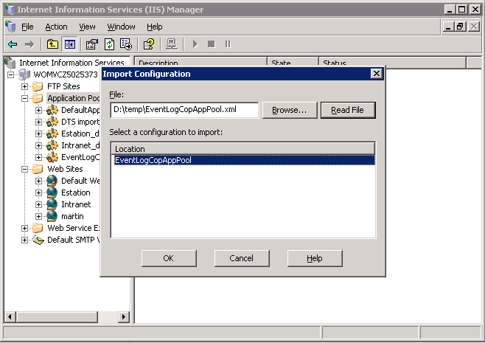

- Right-click EventLogCopAppPool in Application Pools -> Properties -> Identity. Set user name and password of previously created user.

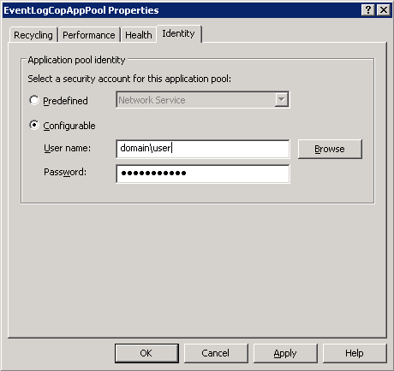

- Right-click Web Sites -> New -> Web Site (from file). Browse for the EventLogCopWeb.xml file in the temp directory. Click Read button, highlight EventLogCop and click OK.

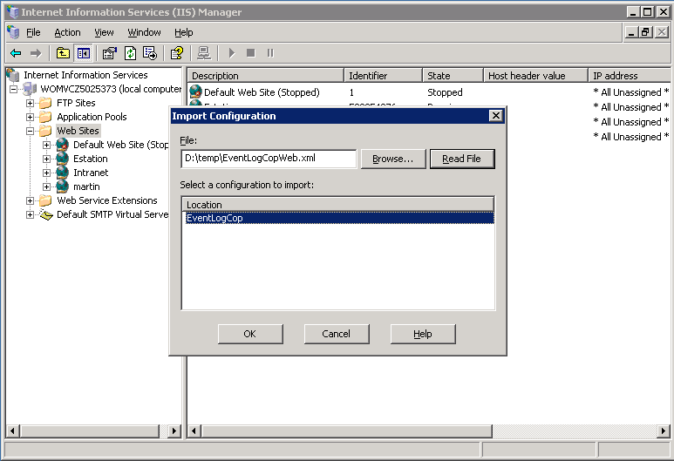

- Right-click EventLogCop in Web Sites -> Properties. In the Web Site panel enter the TCP port you want to use (default 7010).

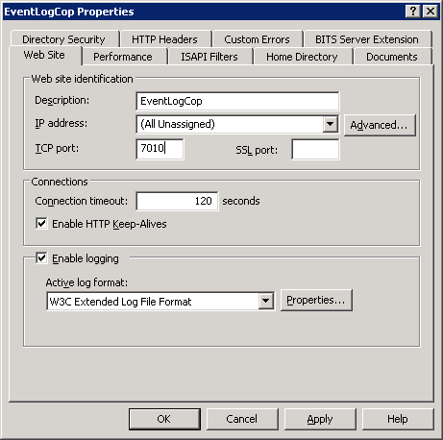

- In the Home Directory panel check if Local path points to the directory C:\Program Files\EventLogCop\WebGUI, where you copied the files. Check if Applications pool is set to EventLogCopAppPool.

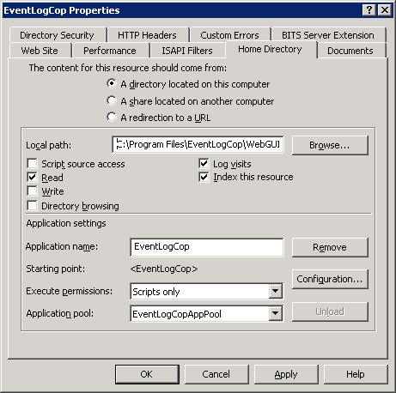

Un-installation instructions

Un-install WebGUI
- Start Internet Information Services Manager from Administrative Tools.
- Remove EventLogCop Web Site and EventLogCopAppPool Application Pool.

Un-install EventLogCop service
- Run file “RegSvc.exe /u” from C:\Program Files\EventLogCop.
- Delete EventLogCop folder from C:\Program Files\.

Un-install database
- Open MS SQL Enterprise Manager and delete EventLogCop database.
- Un-install the MSDE (optional).

Setting permissions on monitored hosts

Windows 2000 Professional, Server and Windows XP
You do not need to set any permission on monitored hosts. However, because of security limitations it’s not possible to monitor the Security Log unless you put the user under which EventLogCop service is running into the Administrators group. This is not recommended because of a possible security breach.

Windows 2003 Server
This part is little bit tricky. It’s really difficult to set permissions on Event Logs. (Why did it the Microsoft guys so complicated?)

WARNING: If you use Registry Editor incorrectly, you may cause serious problems that may require you to reinstall your operating system. I cannot guarantee that you can solve problems that result from using Registry Editor incorrectly. Use Registry Editor at your own risk.

- Find out the SID of the user under which the EventLogCop service is running. You may use the SID Translator utility, which is stored at the “SidTraslator” subfolder of the installation zip file or you may download e.g. PsGetSid command-line utility from http://www.sysinternals.com.
- Start regedit tool on the host you want monitor.
- Open HKLM\System\CurrentControlSet\Services\EventLog key.
- Backup the key (File -> Export).
- Select name of event log for which you want to modify access permissions (e.g. Application).
- Edit CustomSD string:
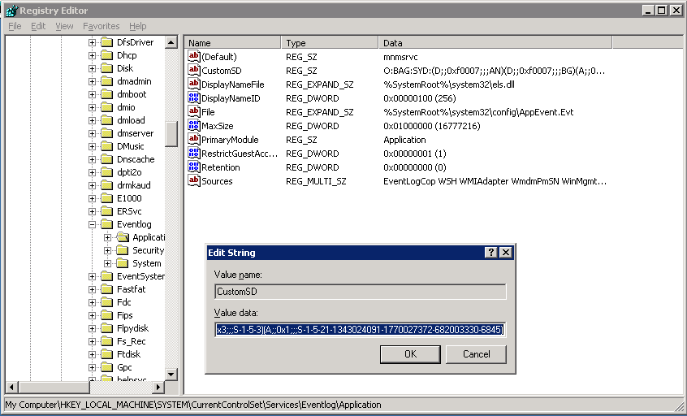
- To the end of the string append the following text:
(A;;0x1;;;SID)
where SID is the string you retrieved in step 1, like:
(A;;0x1;;;S-1-5-21-1343024091-1770027372-682003330-6845)

Please be careful! Do not to delete anything in the original CustomSD string, just append the text described above.

What does each part of text in the brackets mean?

- A … Allow access to user with specified SID.
- 0x1 … Grant read permission only.
- SID … security identifier of user to whom the permission is granted.

More details about setting permissions for Windows 2003 Server event logs you can find here:
- http://support.microsoft.com/default.aspx?scid=kb;en-us;323076

I’ll try to prepare some more user-friendly way to set the permission later if Microsoft doesn’t do it.

Web GUI Description

EventLog Cop Main Page
To connect to the EventLog Cop, simply enter the URL of the server where you previously installed the Web GUI, e.g. http://myserver:7010. The main page will appear.

If you are unable to log into the EventLog Cop, please do one of the following steps:
- Check <authorization> section of web.config file, stored in Web GUI root folder (C:\Program Files\EventLogCop\WebGUI), if it’s set according to the installation instructions.
- In Internet Explorer in Tools -> Internet options -> Advanced, uncheck Security -> Enable Integrated Windows Authentication.

There are three separate frames displayed on the screen:

- Information about the user name of the logged user, status of service and number of changes pending for initialization are located in the right side of top frame.
- Main menu is located in the left frame.
- The main window in the central frame displays actual content for command selected from left menu.

Reports

The Reports page of EventLog Cop displays events from monitored hosts. At the top of the Reports content windows there is an advanced filter which can be used to limit the number of events displayed by setting following parameters:

- Source – when set, only events from the selected source will be displayed.
- Group – when set, only events from the selected group of events will be displayed.
- Date From; Date To – only events between the selected dates will be displayed.
- Log Type – when set, only events of the selected type (Warning, Error, etc.) will be displayed.
- Computer – when set, only events from the selected computer name will be displayed.
- Source – when set, only events from the selected event source will be displayed.
- EventID – when set, only events with the specified Event ID will be displayed.
- User – when set, only events from the specified user will be displayed.

The table below the filter lists events according to configured filter. The table consists of the following columns:

- Type of event (Warning, Error, etc.).
- Computer, where the event occurred.
- Date and Time, when the event occurred.
- Source of the event.
- EventID associated with the event.
- User associated with the event.

By clicking on any row the detail information about the event will be shown.

Collectors

The collector is the most important part of the application. Each collector connects to the selected computer in given time intervals and downloads the events to the SQL database. By clicking the Collectors item in the left menu you can view, modify, add or delete the collectors. The list of collectors consists of the following columns:

- Enabled – indicates if the collector is enabled or disabled.
- Access – indicates if the target computer is accessible. By holding the mouse cursor over an inaccessible computer icon for a short time, the reason for inaccessibility is displayed as a tooltip.
- Computer – the name of the monitored computer.
- Log – the name of the monitored event log.
- Interval – the interval, in minutes, in which the new events are downloaded to database.

By clicking any of the rows in the table the Detail of Collector form will be displayed.

By clicking the NEW button a New Collector form will be displayed.

Detail of Collector

This page is used for adding, modifying or deleting existing collectors. The following fields can be set:

- ID – shows the ID number of the collector. This value is read only.
- Computer – the Netbios name, DNS name or IP address of the monitored host. Once the collector is set, it cannot be changed. If you need to change the name of the monitored host, you have to delete and re-create the collector.
- Log – the name of the monitored event log.
- Enabled – enables or disables the collector.
- Interval – specifies how often the events from the selected host will be downloaded to the database.
- Description – optional description of the collector.
- Check Access – if checked, the warning message will be sent to the defined e-mail address when the monitored host is not accessible.
- Mail To – e-mail address to where the warning e-mail will be sent.
- Subject – the subject of the message.

By clicking the SAVE button the changes will be stored.
By clicking the DELETE button the selected collector will be removed.

Note: You need to set access permission on the monitored host in order to make EventLogCop work properly. Please check the previous chapter for instructions on setting access permissions
.
Note: The status of the service is refreshed each 15 minutes, so it could take some time before the changes you made come into effect.

Groups

Groups of collector make it easy to display requested reports or send alerts. Each collector could be a member of an unlimited number of groups. On this page it’s possible to view, add, modify or delete the group of collectors.

By clicking on the name of the group the Details of Group form will be displayed.
By clicking the NEW button a New Group form will be displayed.

Detail of Group

The page is divided into two parts. In the top part it’s possible to change the name of the group. In the bottom part you can add or remove the member collectors to or from the group. Hold the Ctrl key to select multiple collectors and click on appropriate arrow to assign or remove the collectors.

Alerters
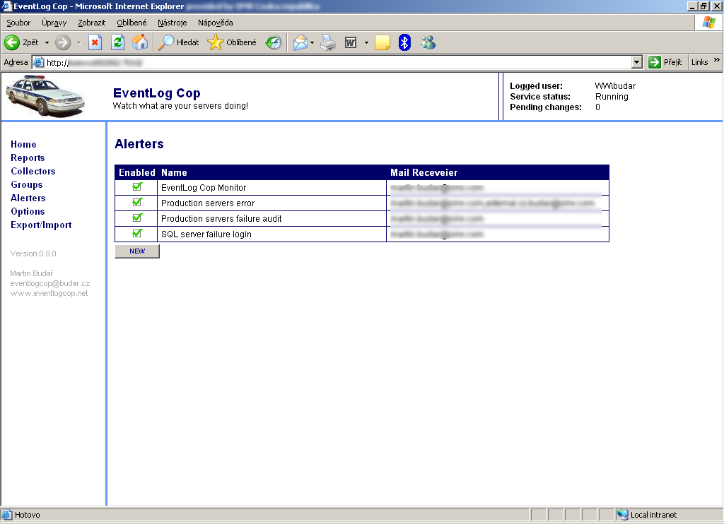

Alerters are used for sending e-mail warnings. If any event gathered by the collectors meets the conditions defined in the Alerter, an e-mail message is sent to the given e-mail address. On this page it’s possible to view, add, modify or delete the alerters.

By clicking on the selected row the Details of Alerter form will be displayed.
By clicking the NEW button, a New Alerter form will be displayed.

Detail of Alerter
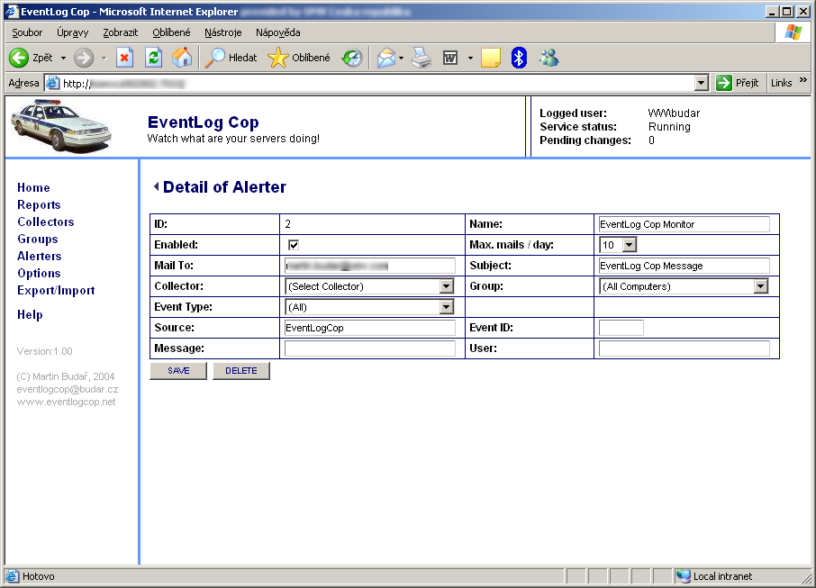

The following fields are used to define the alerter:

- ID – the ID number of the alerter. This field is read only.
- Name – the name of the alerter.
- Enabled – enables or disables the alerter.
- Max. mails / day – maximum number of mails which could be sent in one day by the selected alerter.
- Mail To – e-mail address of the recipient of the message.
- Subject – subject of the message.
- Collector – if set, only events from the selected collector will be checked and eventually e-mailed.
- Group – if set, only events from the selected group will be checked and eventually e-mailed. Select All Computers group if you want to check all events.
- Event Type – if set, only events of the selected type will be checked and eventually e-mailed.
- Source – if set, only events from the selected source will be checked and eventually e-mailed.
- EventID – if set, only events with the selected event ID will be checked and eventually e-mailed.
- Message – if set, only events with the given words in the event body will be checked and eventually e-mailed.
- User – if set, only events from the selected user will be checked and eventually e-mailed.

Options
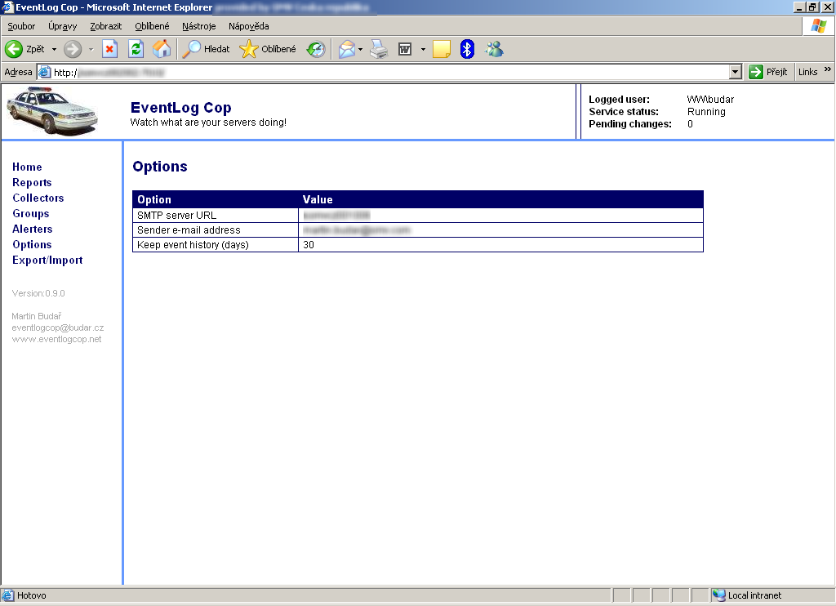

Use this page to set general settings:

- SMTP server URL – the URL of the SMTP server which is used for distribution of e-mails by alerters and collectors.
- Sender e-mail address – email address of the messages sender.
- Keep event history (days) – specifies how long the events will be retained in the database. Older messages will be deleted.

Export/Import
Use this page to export collectors and alerters to an XML file or to import collectors or alerters from an XML file.

